صورة تحتوي على نص, جهاز, متر

تم إنشاء الوصف تلقائياً

**software Project**

**Name of Project:**

**Airline Reservation**

**Supervised By:**

**- Dr: Marwa Refaee**

**Submitted By :**

**- Abdel Rahman Ghoniem Ghoniem Abdel Azim**

**- Mohammed Abdul Karim Mohammed Alammar**

**- Mohammed Abdel Motaleb Mohammed Shaaban**

**- Mohammed Ashraf Mohammed Abdel Aziz**

**-** **Omnia Mohamed Mostafa El Sadny**

Table of Contents

Introduction: 3

Project scope: - 4

Use case model: - 5

Project Description: 6

User Requirements: 6

System Requirements 7

Non-functional requirements: 7

Functional requirements: 7

Activity diagram: - 12

Class diagram: - 13

Sequence diagram: - 14

1ST REGISTRATION & LOGIN SEQUENCE: _ 14

2ND General system sequence: - 15

Prototype:- 16

design: - 23

FORMS: - 30

Test case: - 39

# Introduction:

**Airline Reservation**

**صورة تحتوي على نص, بطاقة عمل, قصاصة فنية

تم إنشاء الوصف تلقائياً**

**Description of the project:**

**Airline reservation system (ARS) are system that allow an airline to sell its inventory (seats).**

**It contains information on schedules and prices and contains a database of reservations (or passenger name records) and tickets issued.**

**The main drive behind establishing our project was our wish to develop the concept of traveling easily, comfortably and elegantly. This is why we have always strived to provide innovative online traveling solutions to travelers around Egypt and travelers from all over the world, middle eastern especially. We proud for provides comprehensive and high-quality services in the travel and tourism sector.**

# Project scope: -

***In* *scope*:**

**1-you can book and reserve airplane seat tickets easily with our interface**

**2-you can register all your personal information and it shall be kept private and safe**

**3-we offer safe domestic flights all over the country**

***Out scope:***

**1-in the future we can update our program to offer also international flights for passengers all over the globe**

**2- we can add a barcode that can be attached to the passenger’s ticket in order to check the authority of the ticket holder at the airport**

**3-we can add a check box for special needed people to make sure we provide the needed assistance on the plane**

# Use case model: -

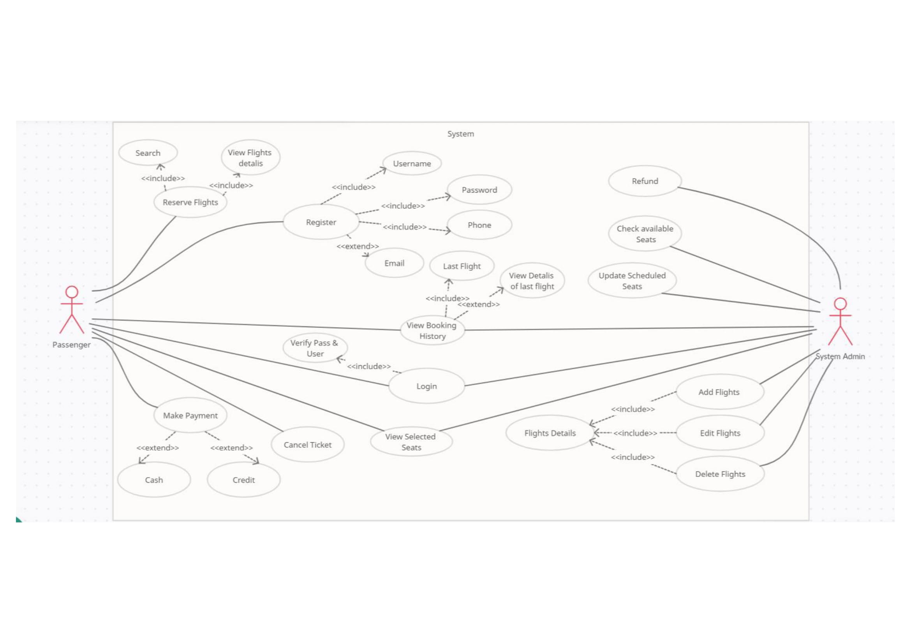

Software Requirements Specification

# Project Description:

Airline reservation system (ARS) are system that allow an airline to sell its inventory (seats).

It contains information on schedules and prices and contains a database of reservations (or passenger name records) and tickets issued.

The main drive behind establishing our project was our wish to develop the concept of traveling easily, comfortably and elegantly. This is why we have always strived to provide innovative online traveling solutions to travelers around Egypt and travelers from all over the world, middle eastern especially. We proud for provides comprehensive and high-quality services in the travel and tourism sector**.**

# User Requirements:

The airline ticket reservation system should help the passenger to easily book an airline ticket within the governorates of Egypt.

* Buying an airline ticket (booking, paying, cancel).
* flight information (determine destination, time, airline name).
* Monitor detailed information about the reservation.

# System Requirements

## Non-functional requirements:

* Usability Requirements

The system is designed for a user-friendly environment so that the passenger can book the flight ticket easily and in an efficient manner

* Reliability Requirements

The system should easily perform passenger registration

Validate, search, add, delete and update reservations

* Efficiency Requirements

The system will help the manager and the passenger to easily access reservations and flight information such as searching for tickets and flight times

## Functional requirements:

System feature: -

(Admin) login

This feature is used by the system administrator to log into the system using their unique name and ID/password.

Administrator name/password is checked at login

**Functional requirements**

* The system must be able to log in the administrator
* The system must be able to verify that the administrator is logged in

(Passenger) login

This feature is used by the passenger to log into the system using their unique name/email/ID and password.

Passenger name/pass is verified upon login

**Functional requirements**

* The system must be able to log the passenger in
* The system must be able to verify the passenger's login

(Passenger) register

This feature is used by the passenger to register into the system by setting up a unique name/email/ID and password and enter their personal information

Passenger name/pass is verified upon login

**Functional requirements**

* The system must be able to register the passenger in
* The system must be able to verify the new passenger's login information

(Passenger): Reserve flights

This feature is used by the passenger to search for suitable flights, their timing, and the ability to book tickets

**Functional requirements**

* The system must be able to add a reservation to the database
* The system must be able to display available flight information and reservations for the passenger

(System Admin): Check available seats

This feature is used by the administrator to check for empty seats and to check if the reservation process can be completed

**Functional requirements**

* The system should be able to check available seats
* The system must be able to confirm the reservation to the passenger

(System Admin) & (passenger): View selected seats

This feature is used by the passenger to select the appropriate seat and category for him, and by the administrator to verify the seat to be reserved by the passenger through the system.

**Functional requirements**

* The system must be able to provide an option for the passenger to select the seat to be reserved
* The system must be able to access the database to see if the seat is bookable or not

(System Admin) (passenger): view booking history

This feature is used by the passenger to know the details of his previous reservations

**Functional requirements**

* The system must be able to access the database to know the passenger's data
* The system must be able to display the passenger's previous travel information

(passenger): Make payment

This feature is used by the passenger to select the appropriate payment method for him and to purchase the ticket

**Functional requirements**

* The system must be able to display the payment methods available in the program
* The system must be able to save the passenger's payment information

(System Admin) (passenger): Cancel ticket

This feature is used by the passenger in the event of a cancellation of the reservation, and by the administrator to know the details of the cancellation

**Functional requirements**

* The system must be able to cancel the ticket for the passenger
* The system must be able to send information to the manager about the cancellation process

(System Admin): Refund

This feature is used by the Administrator to confirm the ticket cancellation and refund to the passenger

**Functional requirements**

* The system must be able to return the money to the passenger
* The system should be able to update the reservation details

(System Admin): Update scheduled seats

This feature is used by the administrator to update reservations, flight times and available seats data permanently

**Functional requirements**

* The system should be able to update flight information continuously
* The system should be able to update the available seats for the new passenger

(System Admin): Flight Details

* This feature is used by the administrator to manipulate all flight details as adding flights, editing flights, deleting flights

**Functional requirements**

* The system should be able to update flight information continuously

# Activity diagram: -

# Class diagram: -

# Sequence diagram: -

## 1ST REGISTRATION & LOGIN SEQUENCE: _

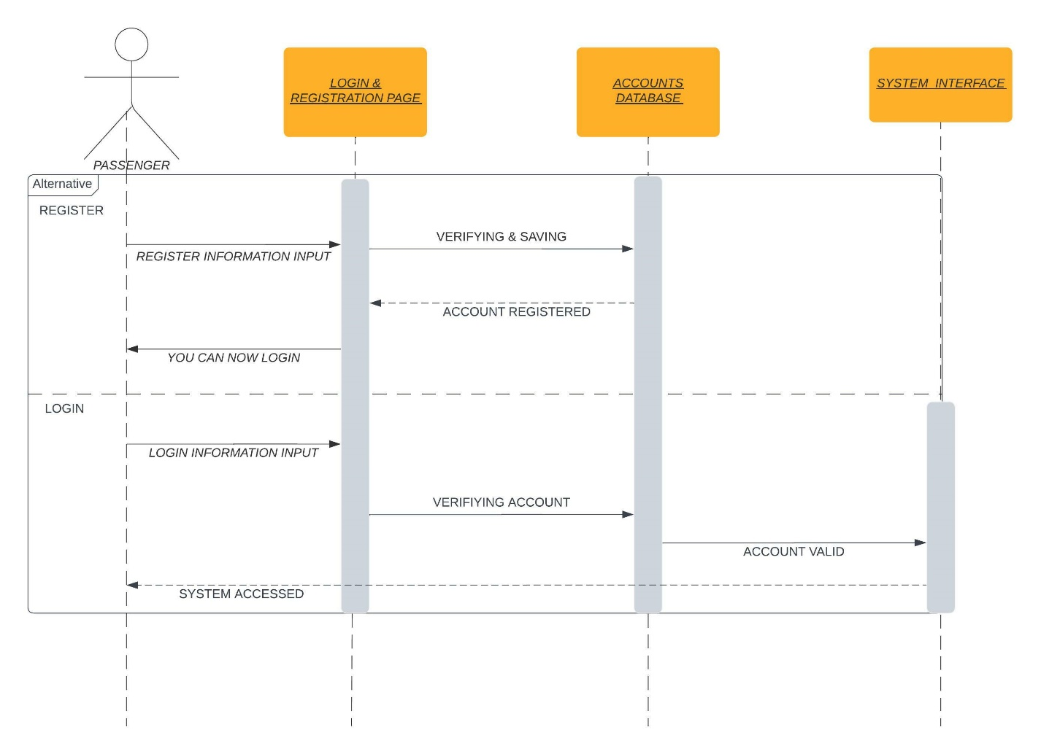

### 2ND General system sequence: -

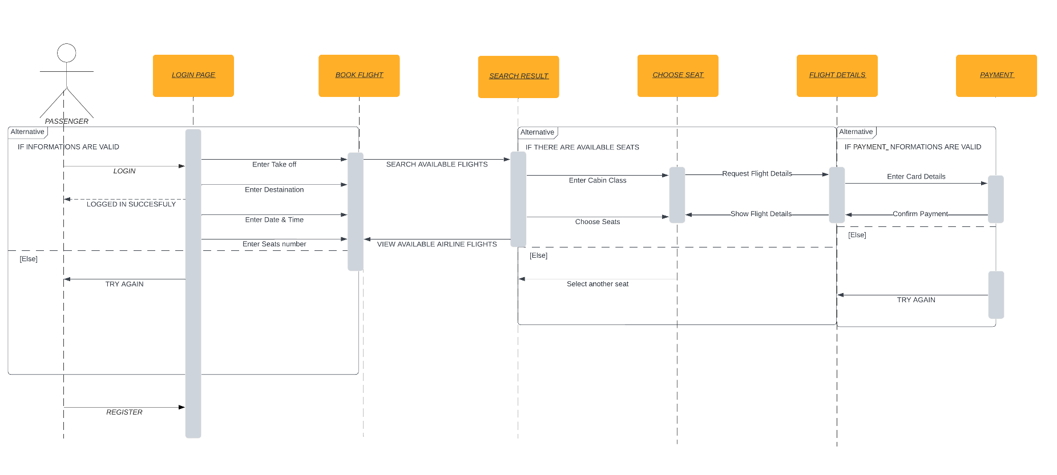

# Prototype:-

**1st Home page:**

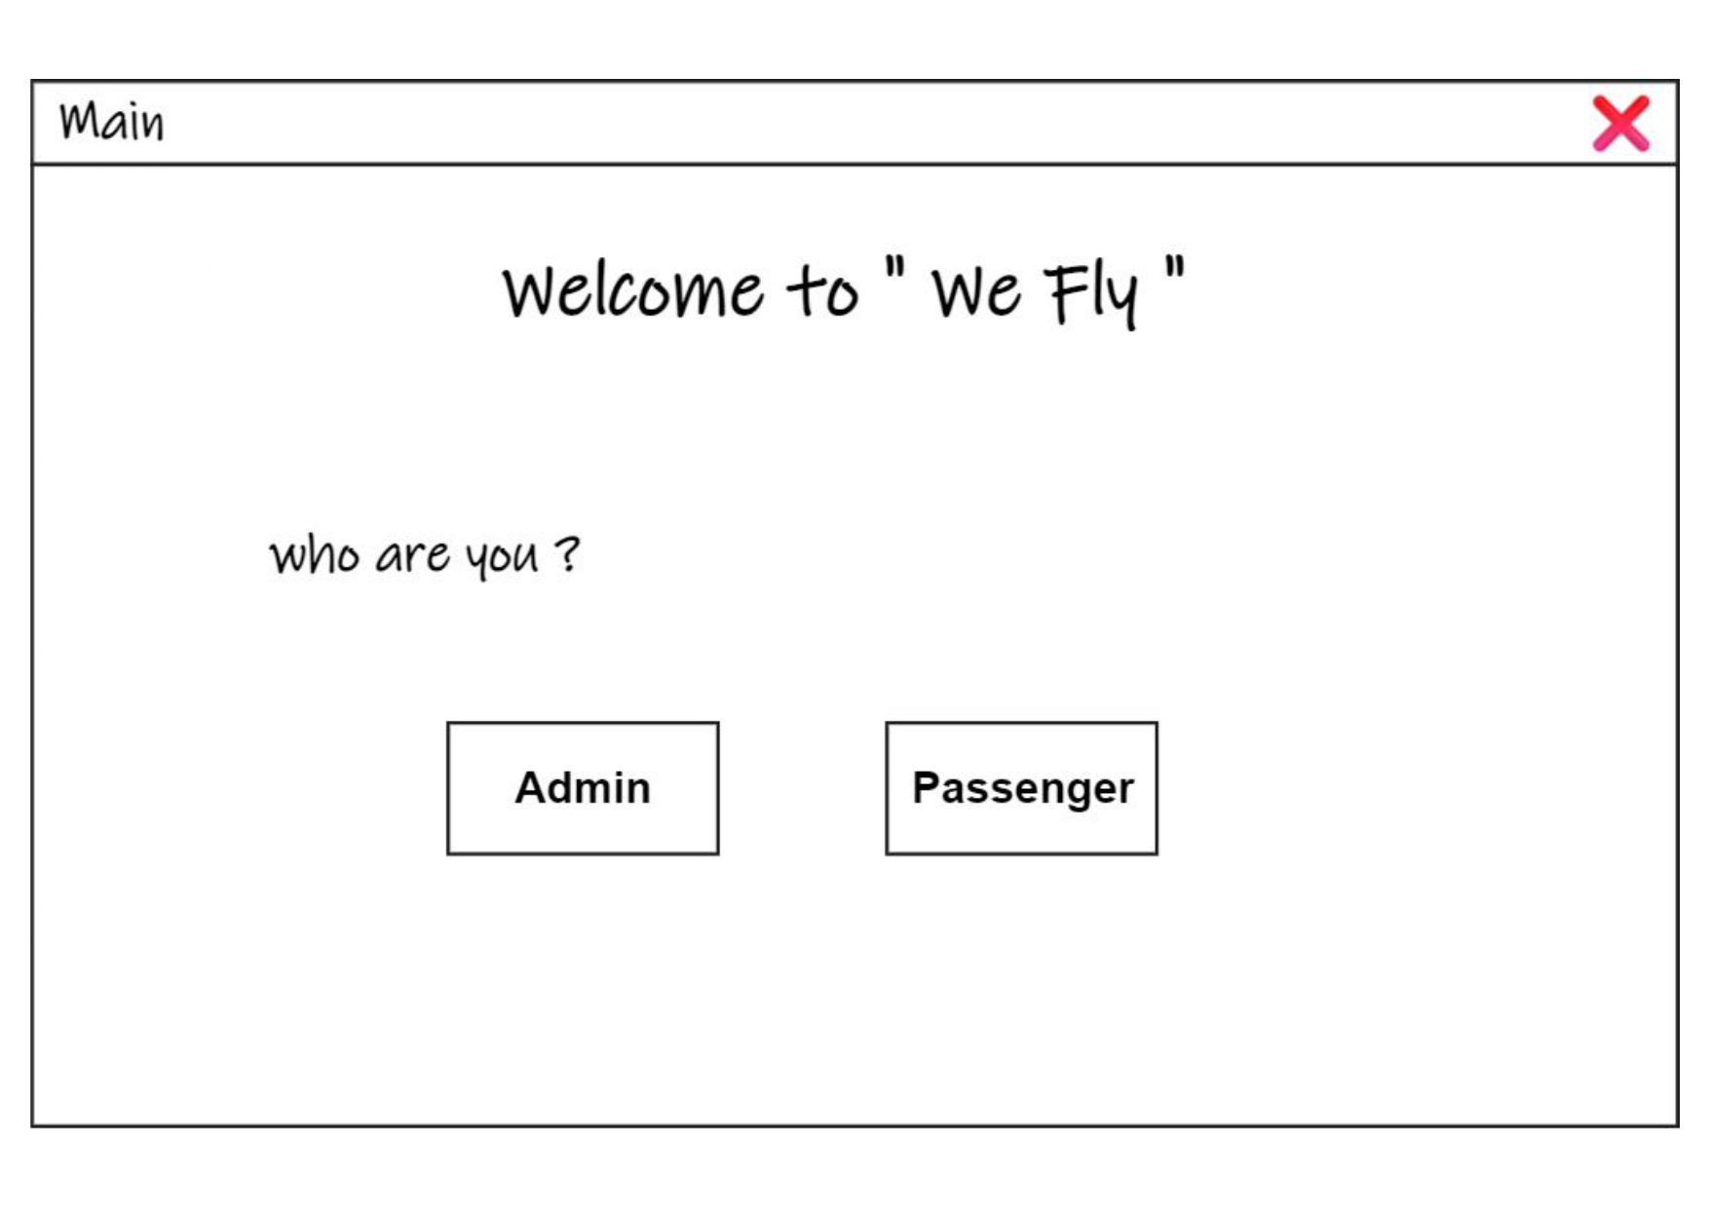

**2nd passenger login page:**

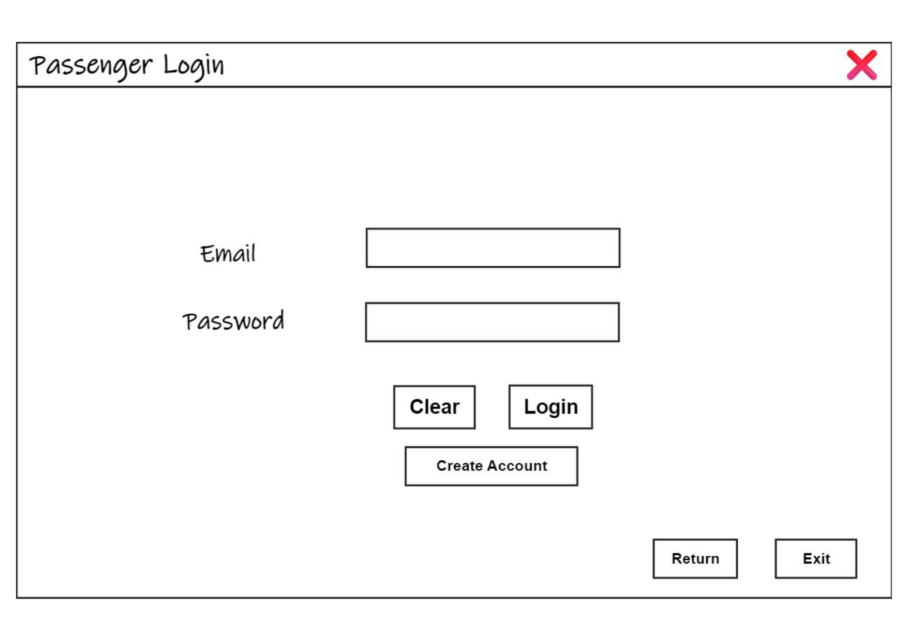

**3rd passenger register page:**

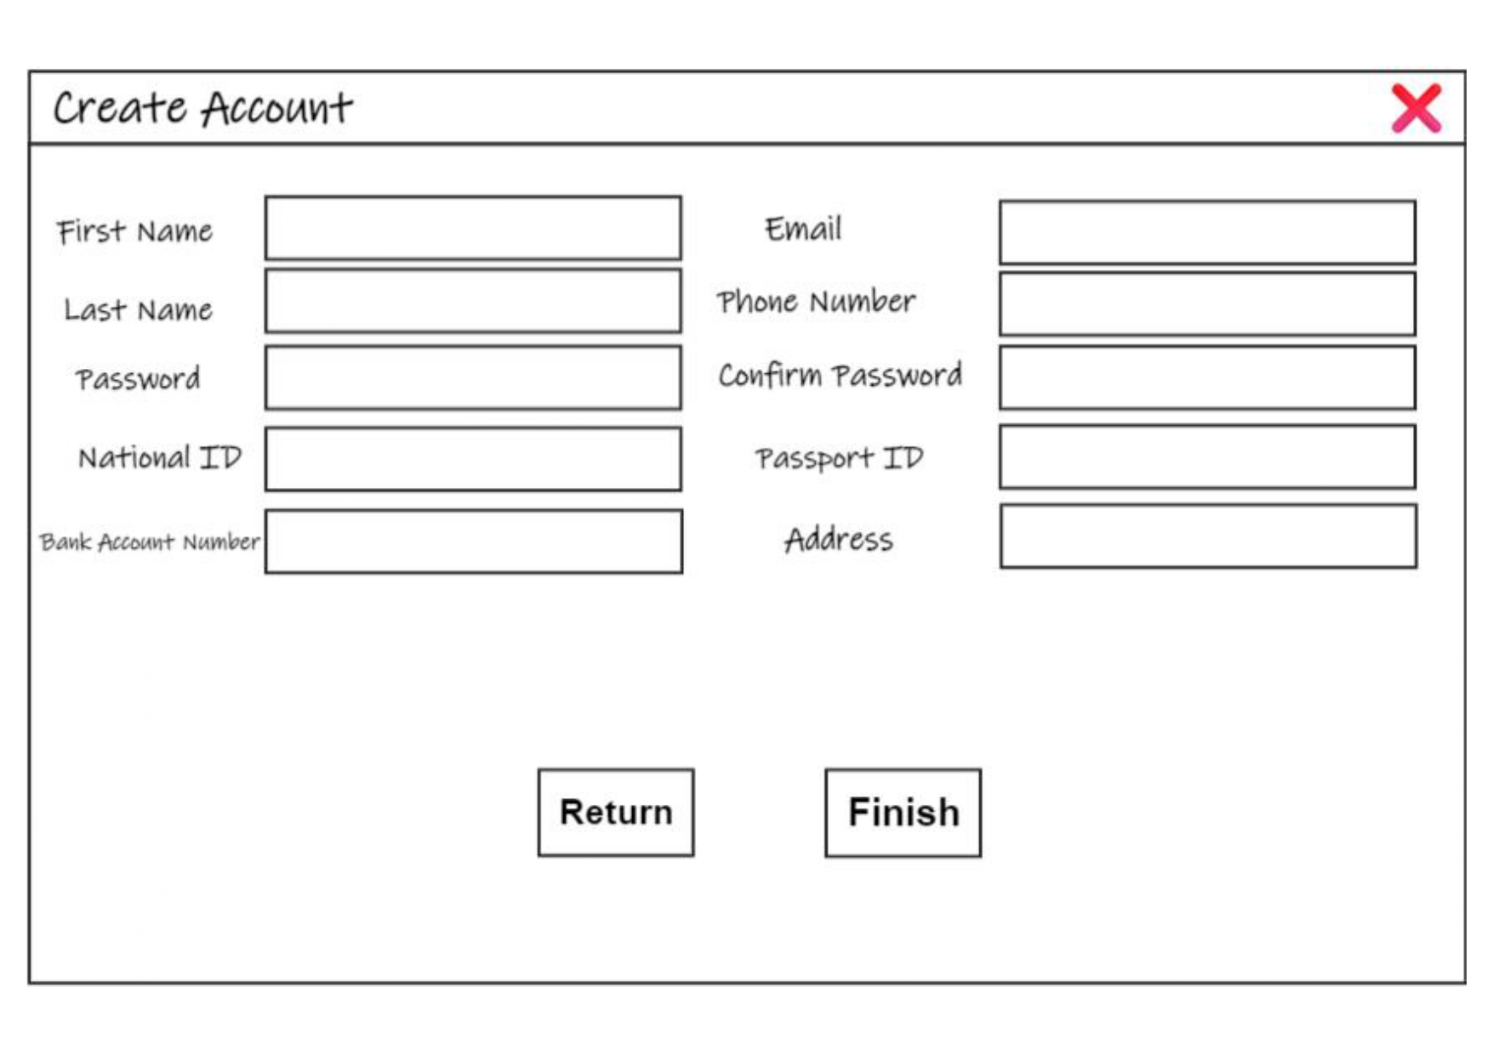

**4th reservation page:**

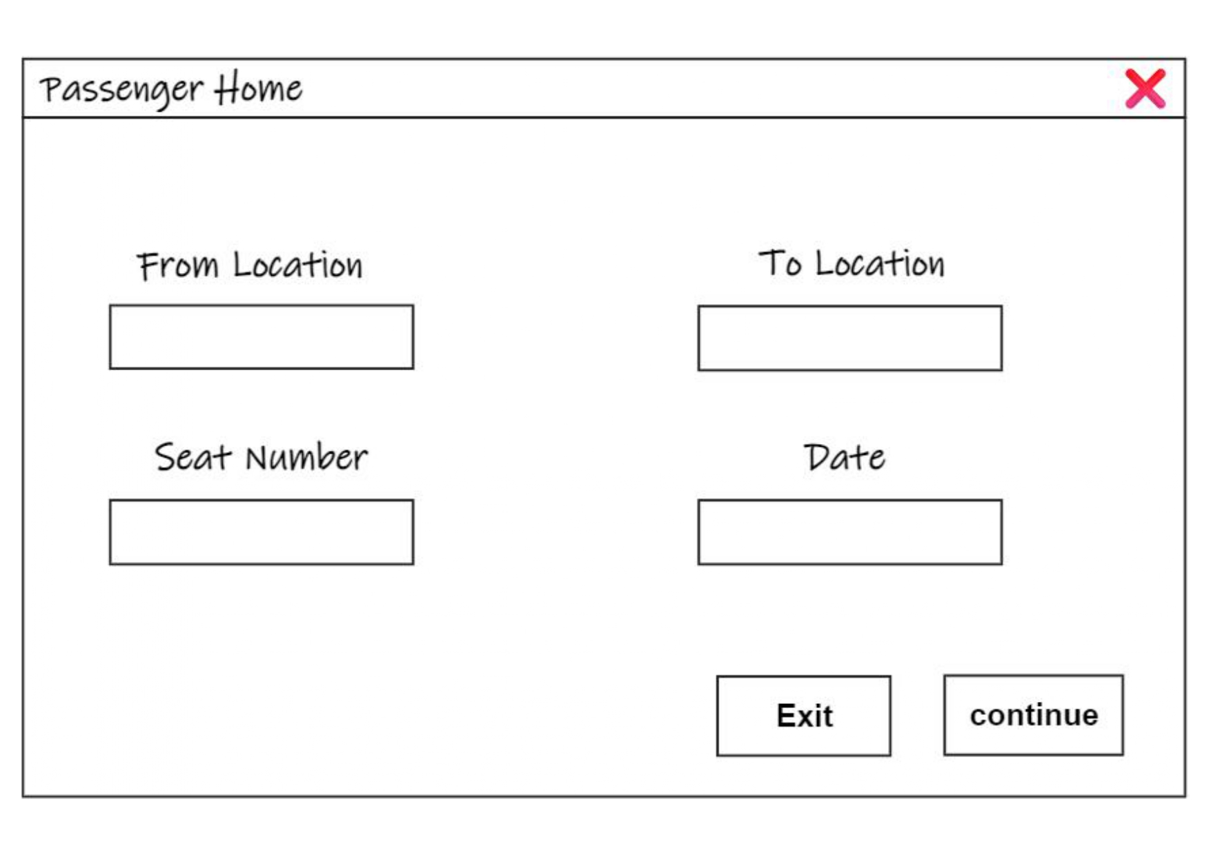

**5th ticket confirmation page:**

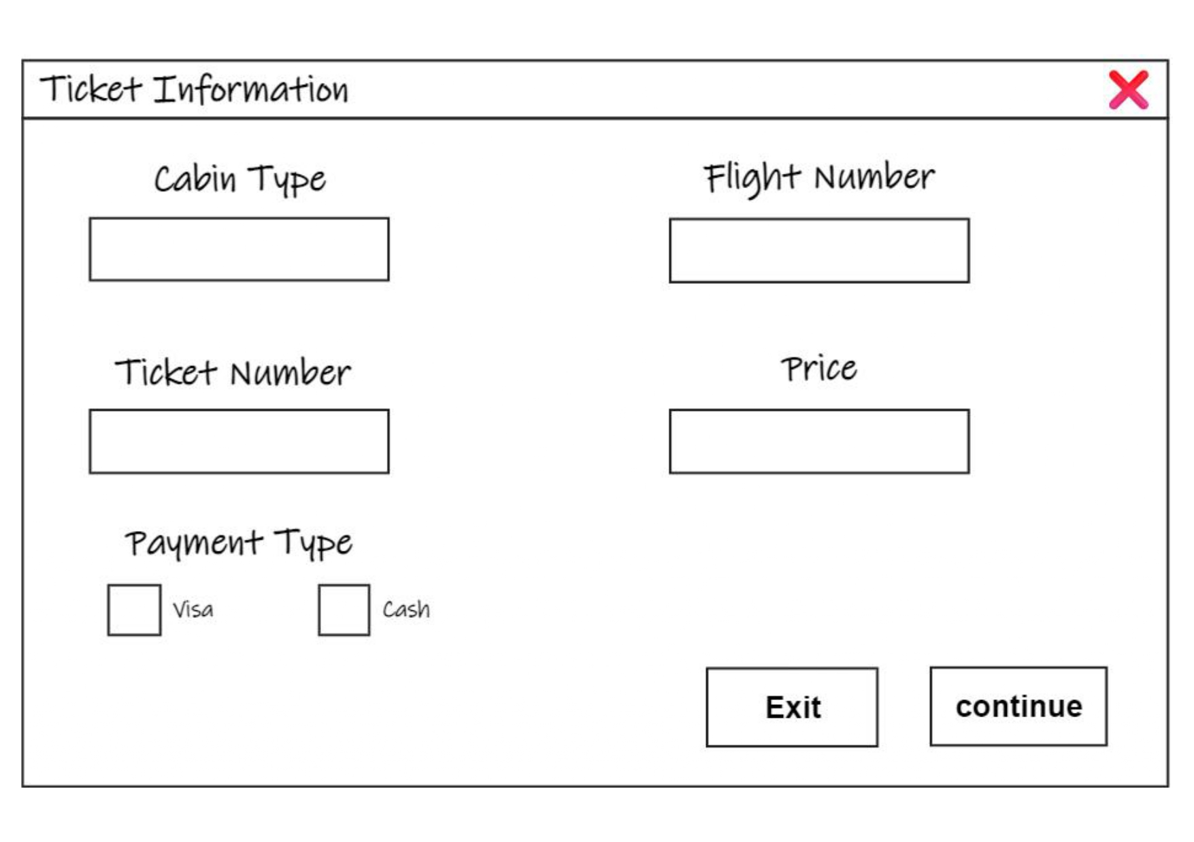

**6th admin login page:**

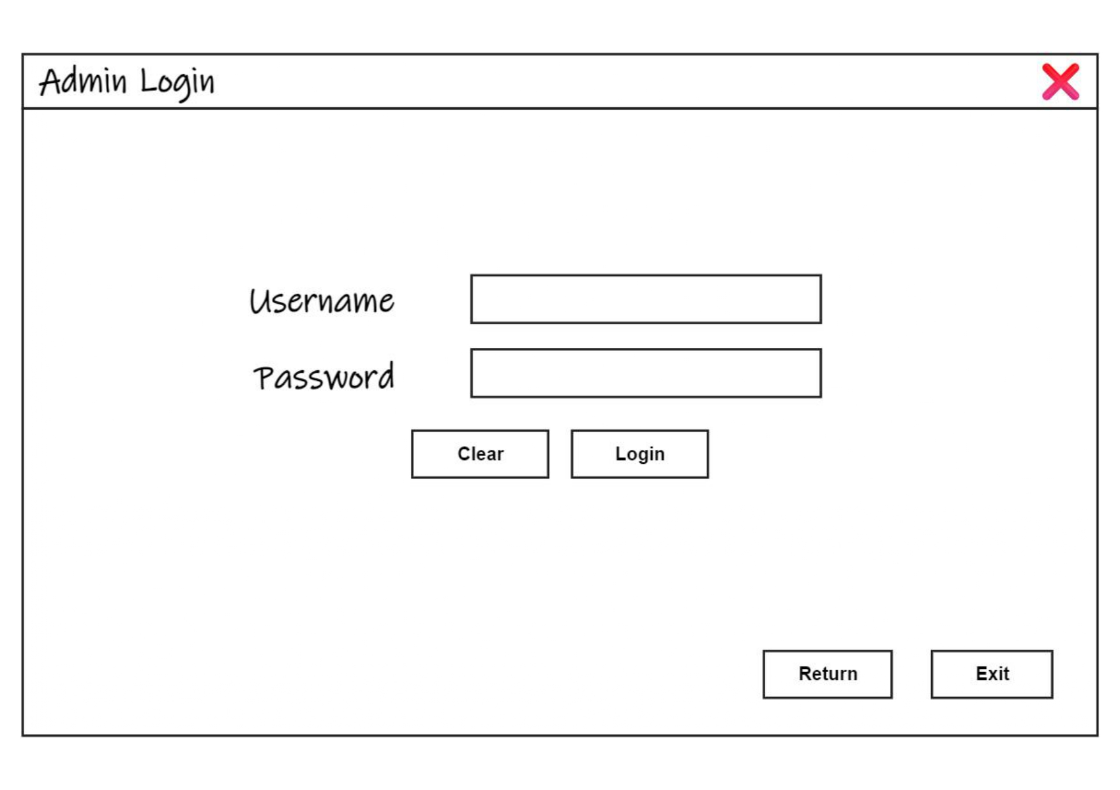

**7th admin data manipulation page:**

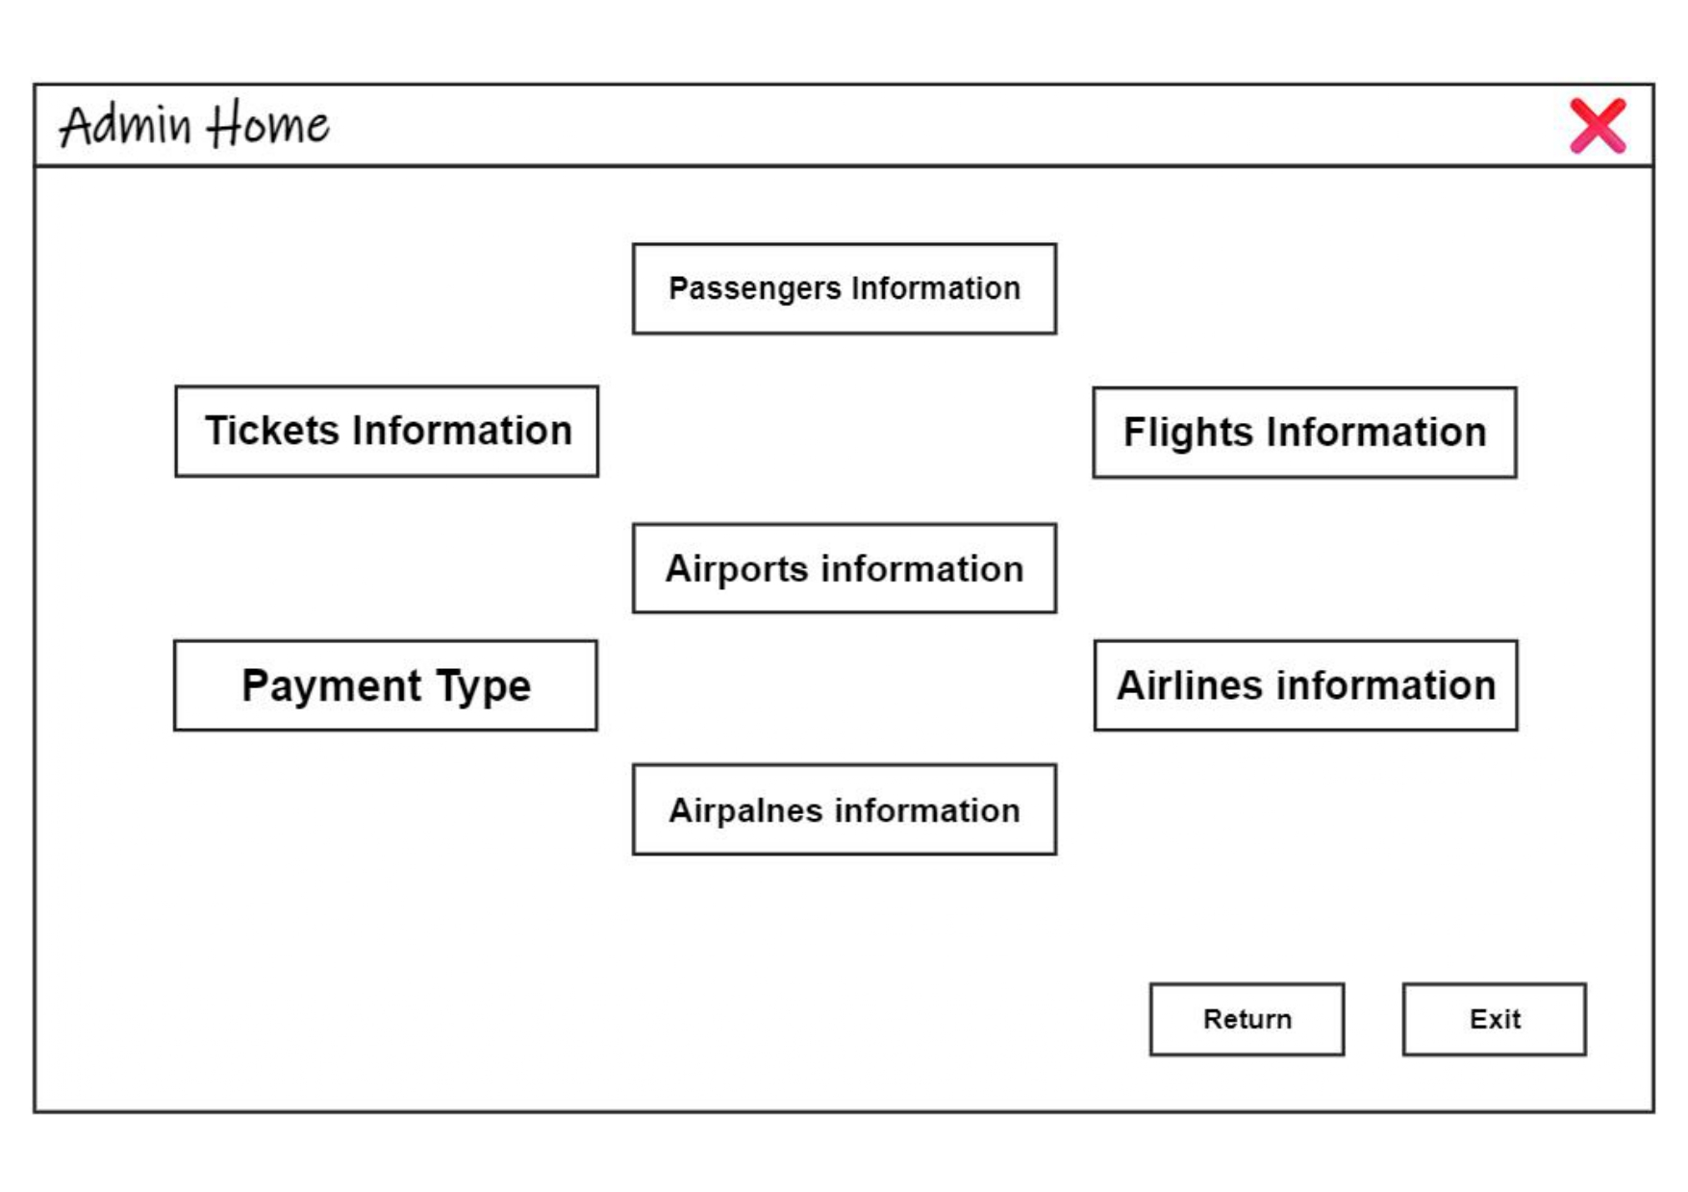

# design: -

**1st login and registration process:**

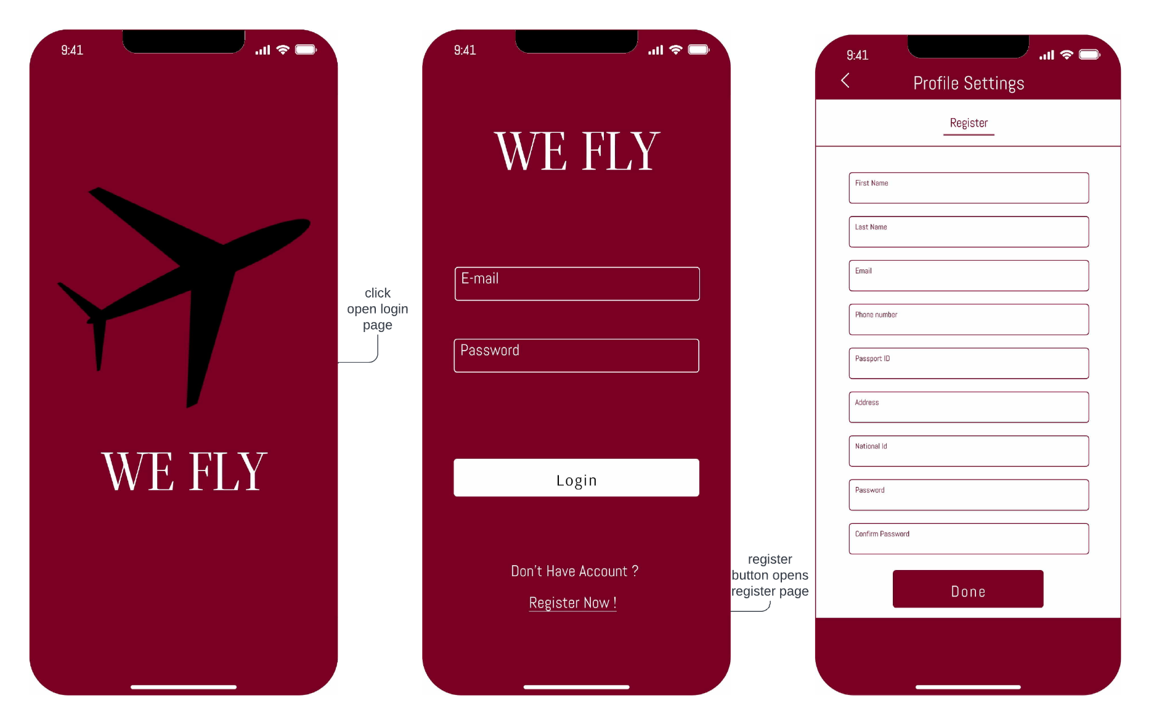

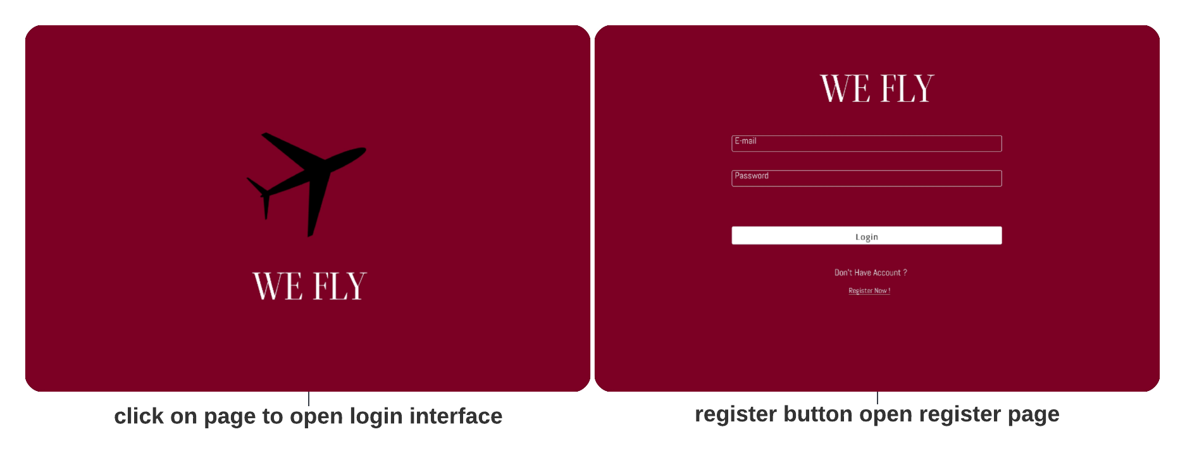

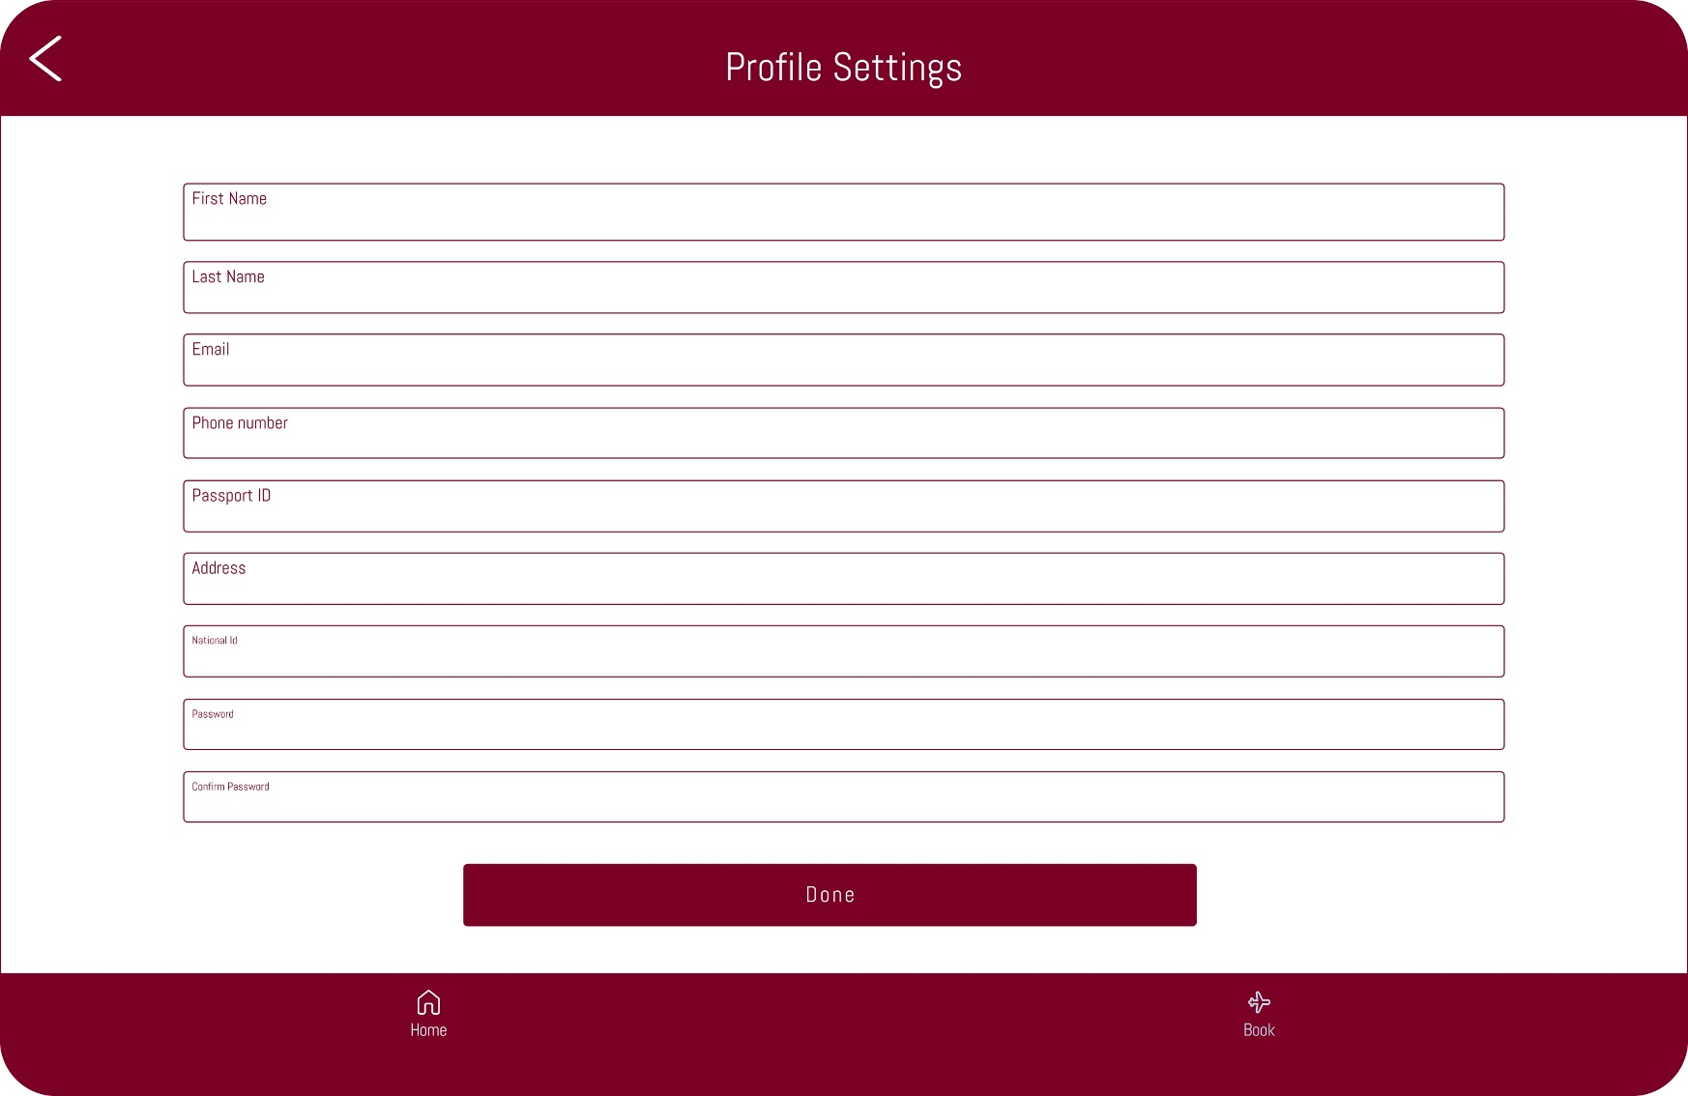**profile register:**

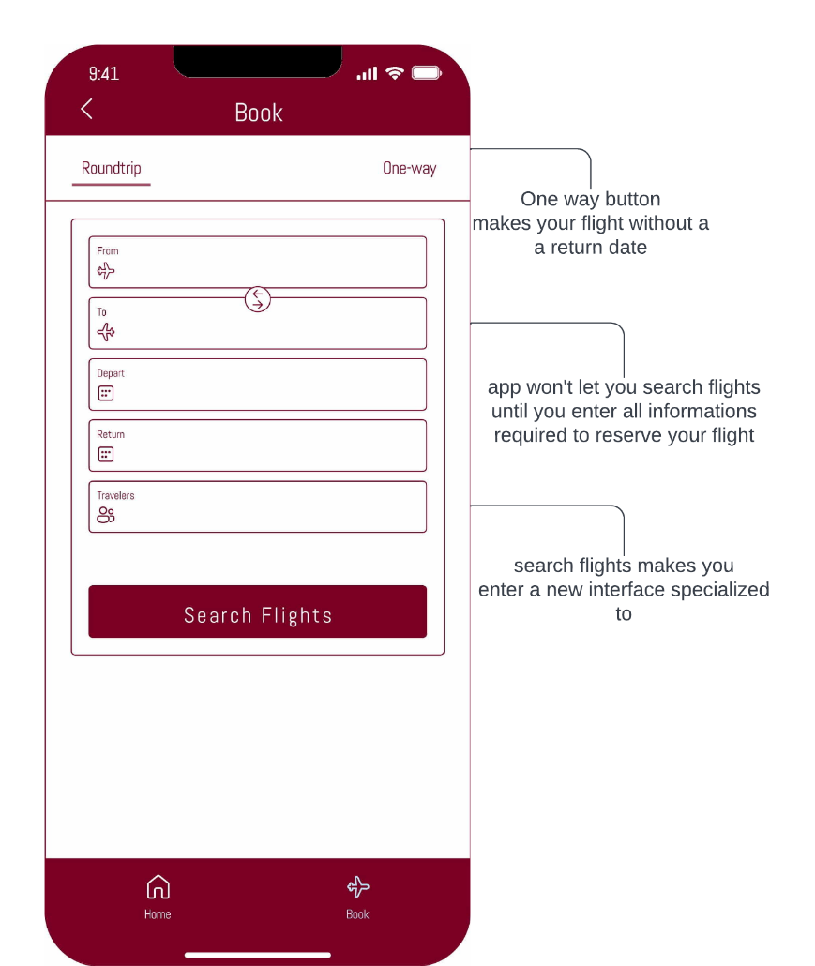**2nd book reservation page:**

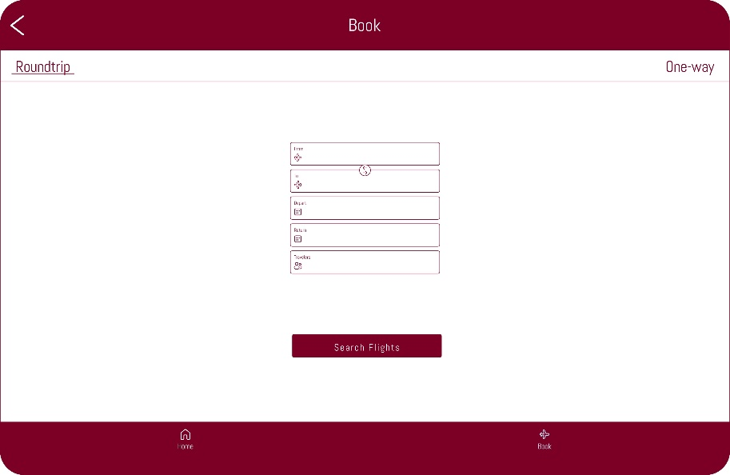

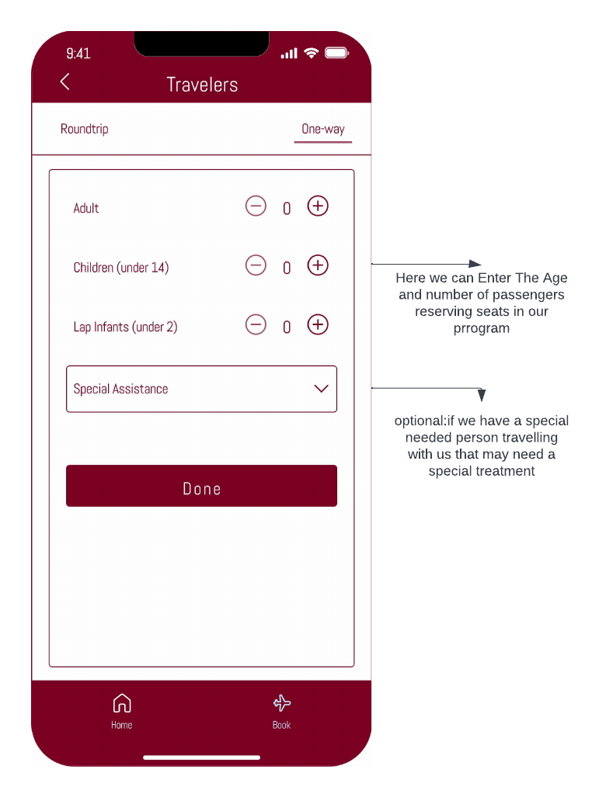**3rd Age & Special need options:**

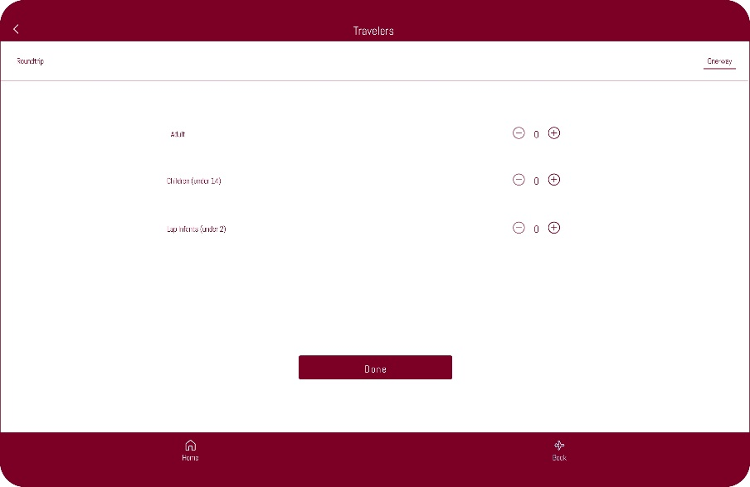

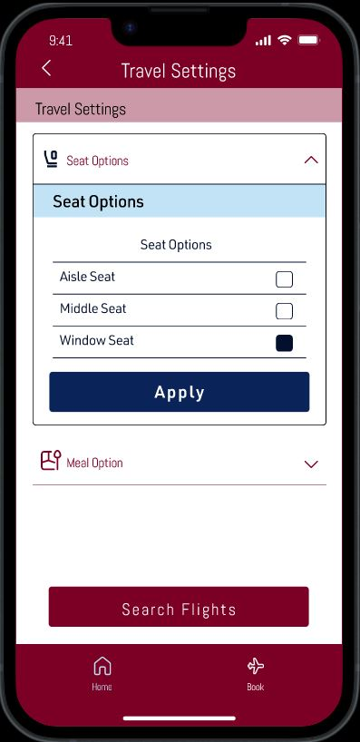**4th Travel seating options:**

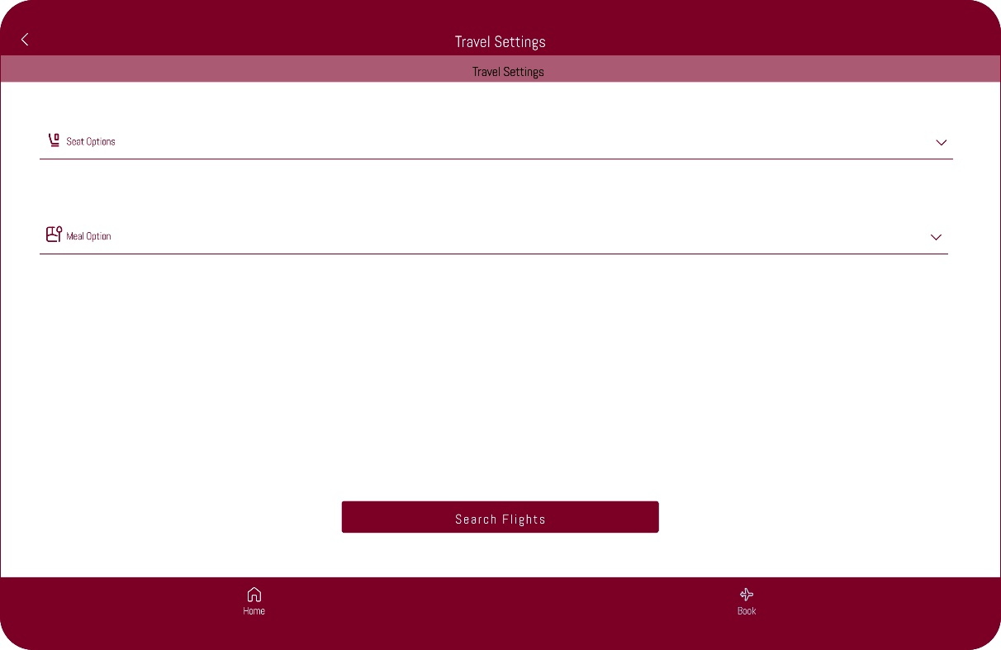

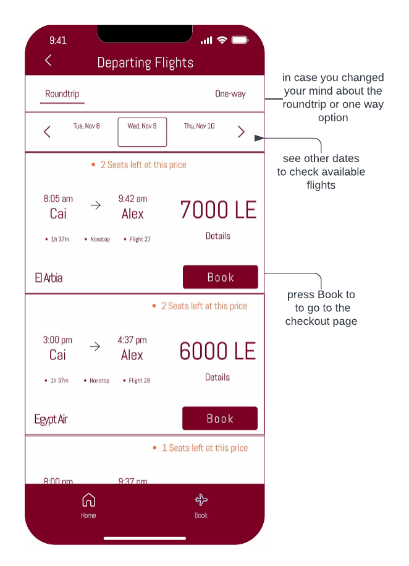**5th Booking flights:**

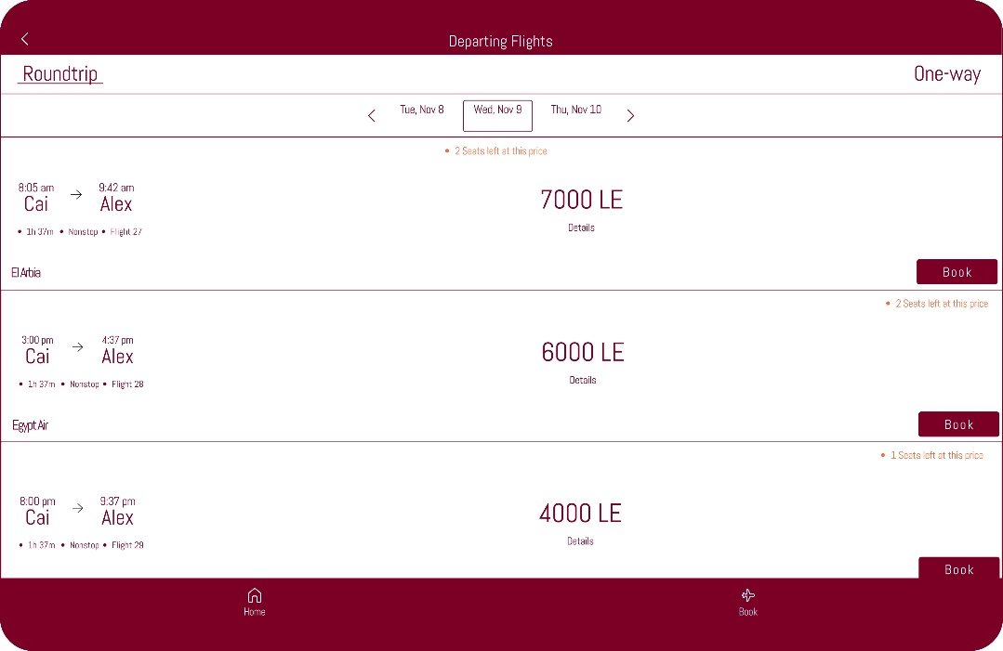

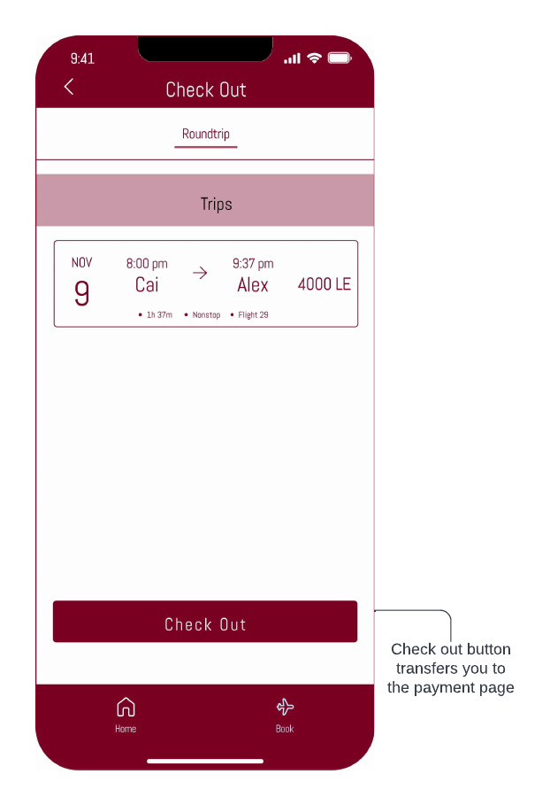**6th check out page:**

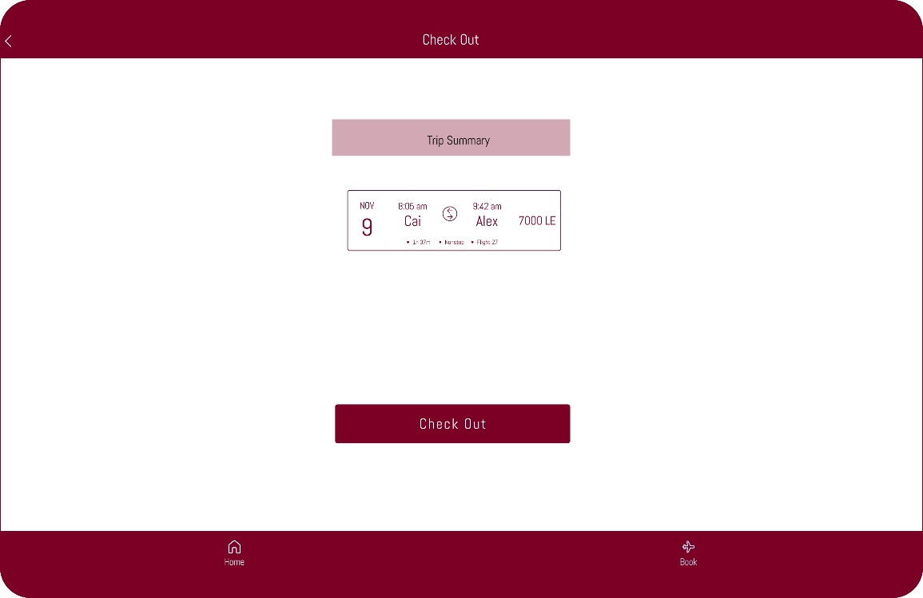

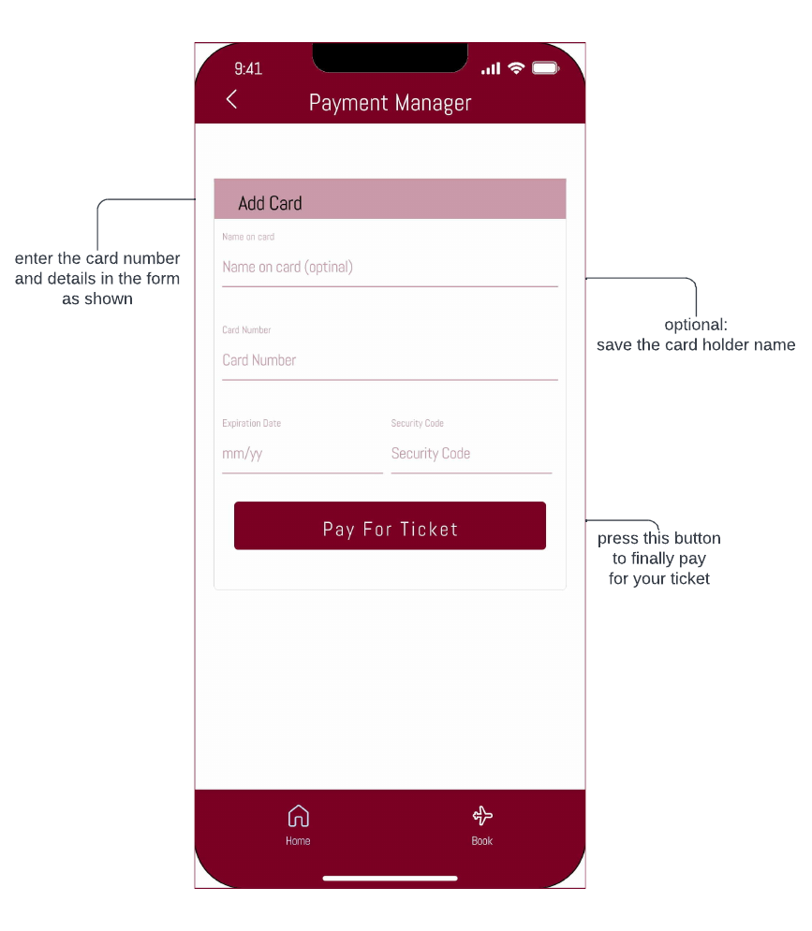**7th payment form:**

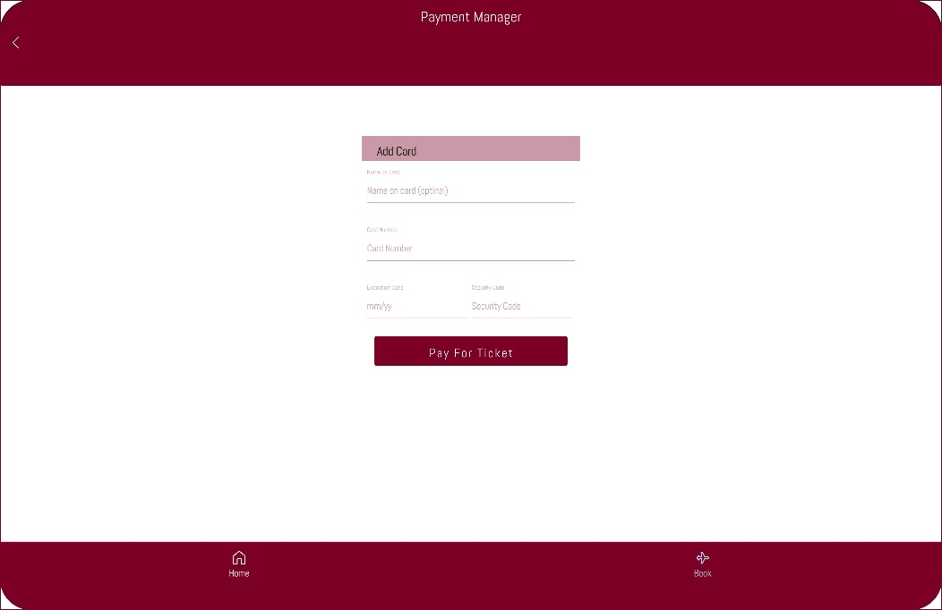

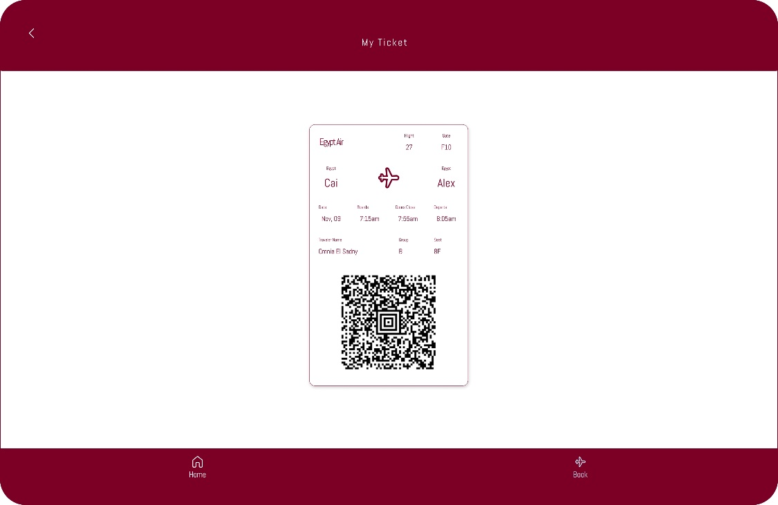**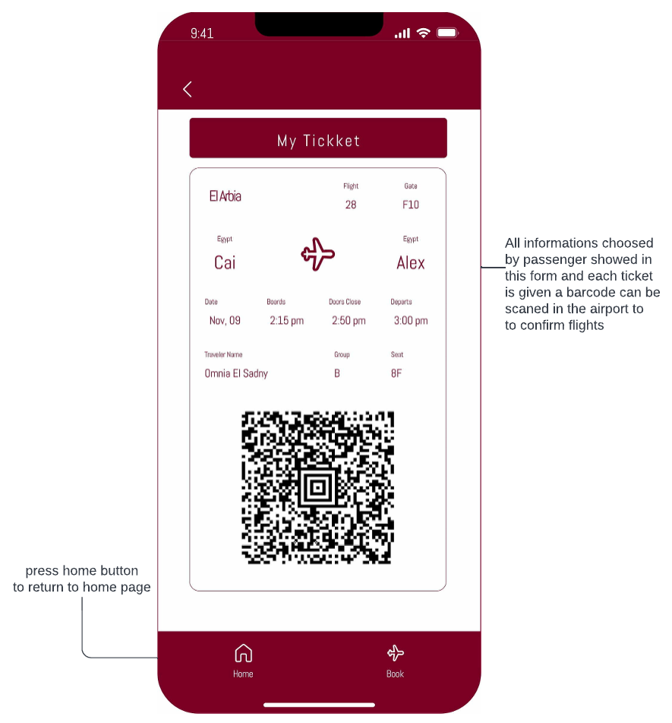8th confirmation page:**

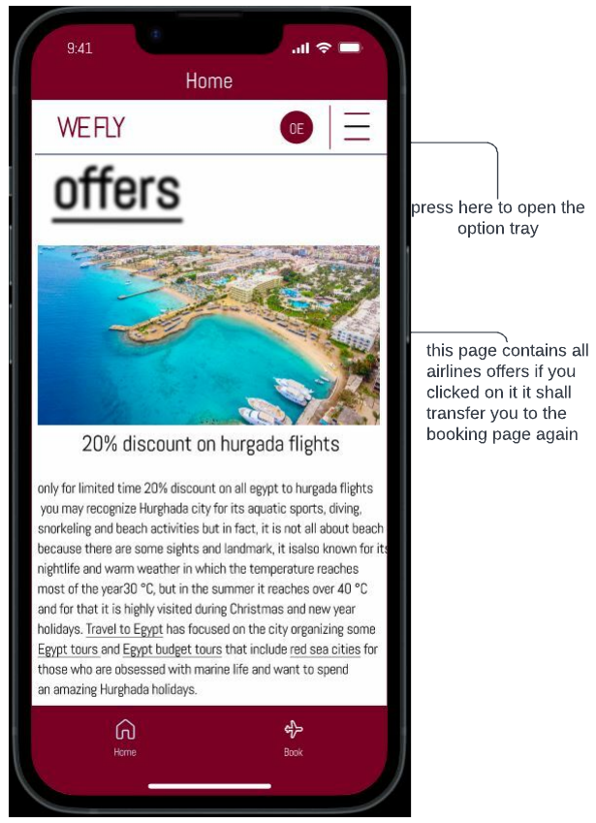**9th returning to home page:**

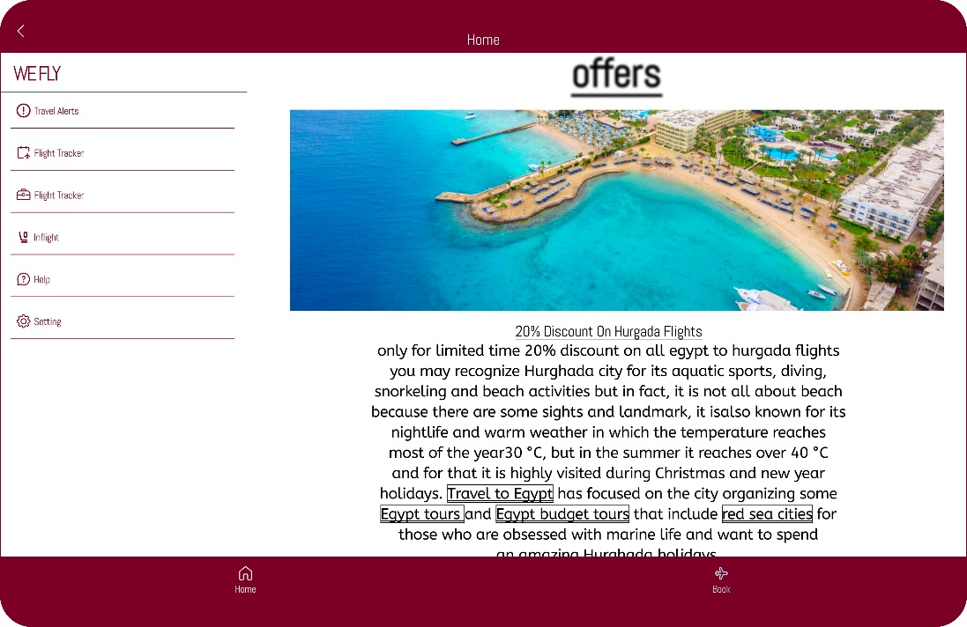

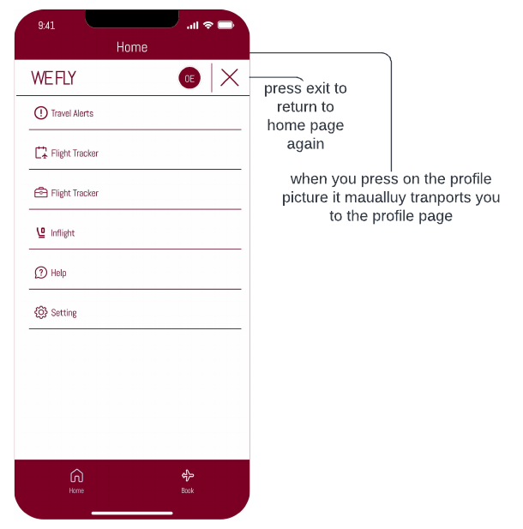**10th homepage options:**

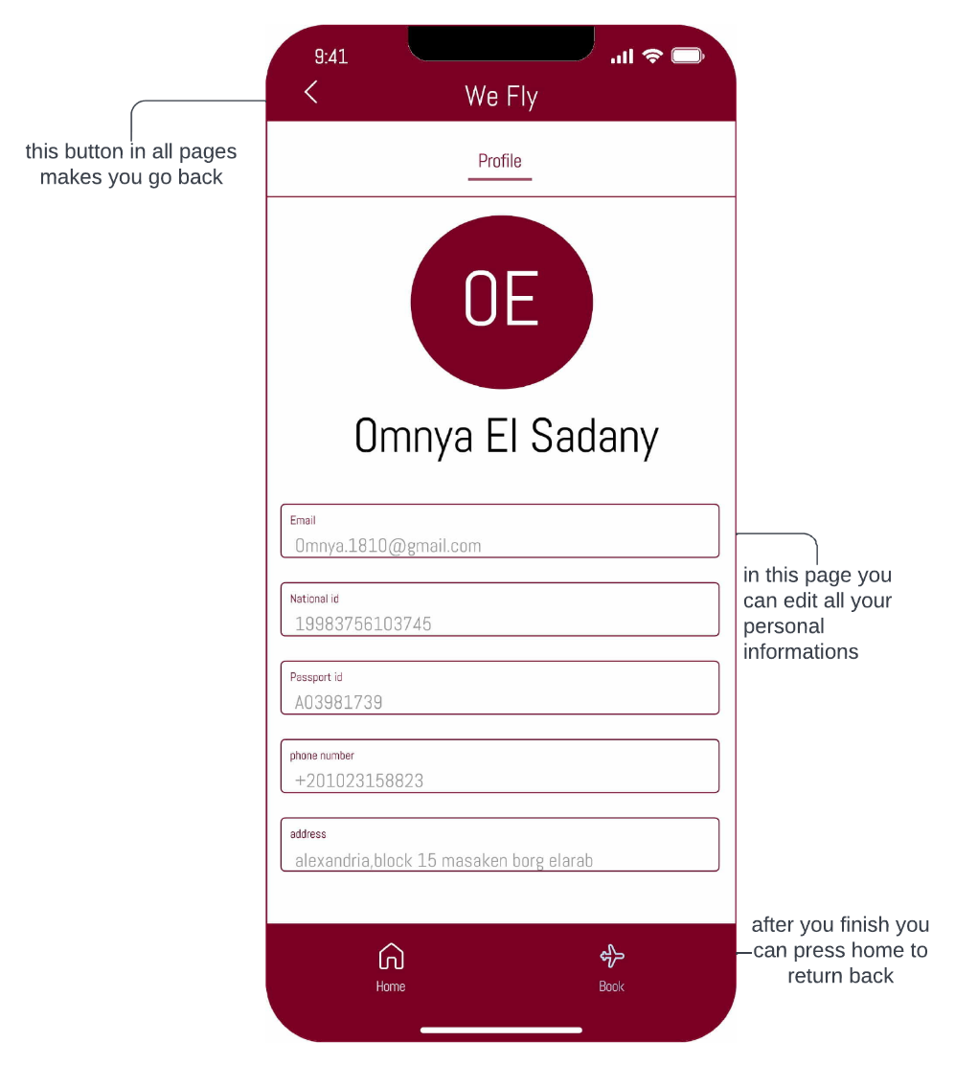**11th profile page:**

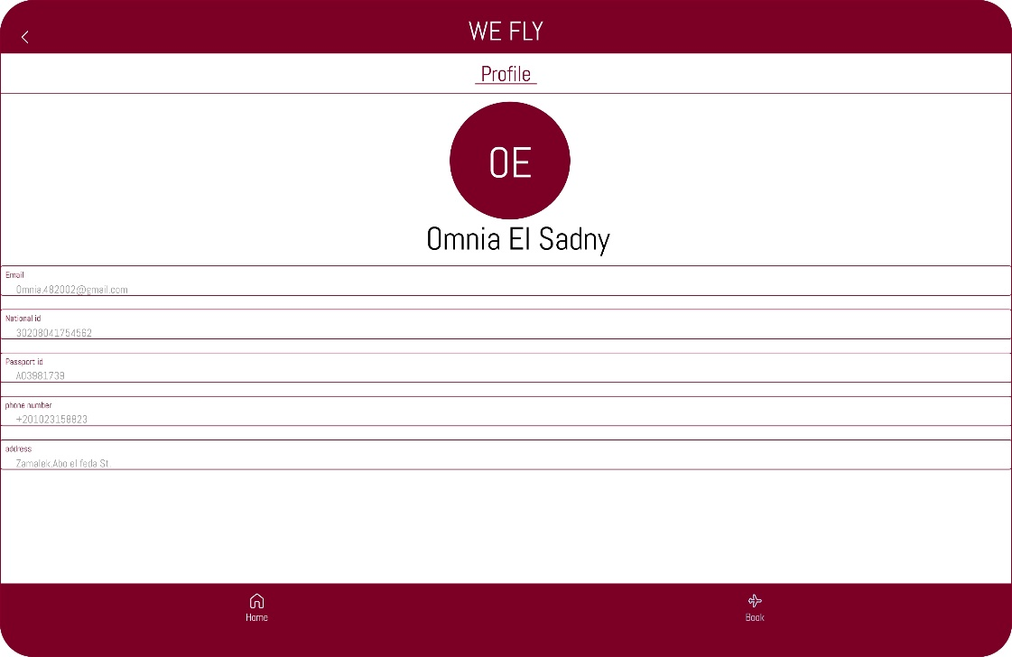

# FORMS: -

1ST user specification: -

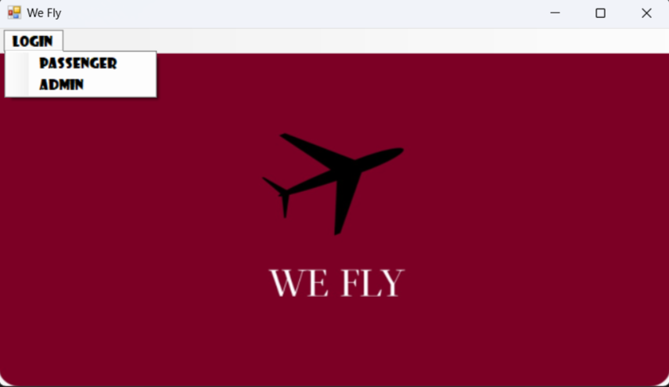

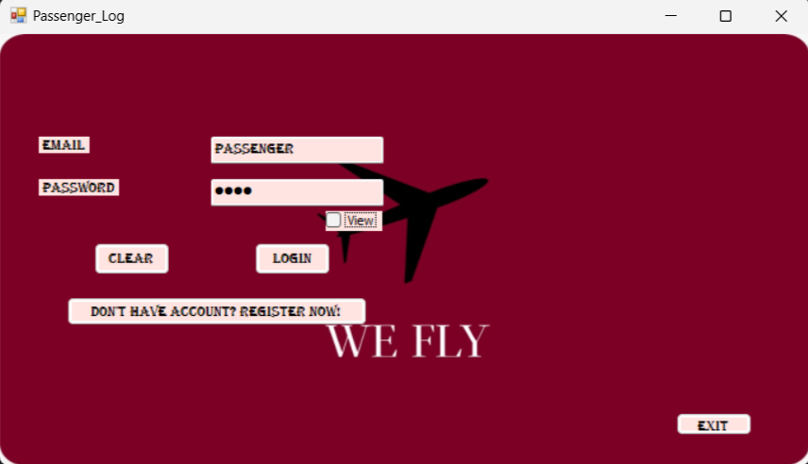2nd passenger log: -

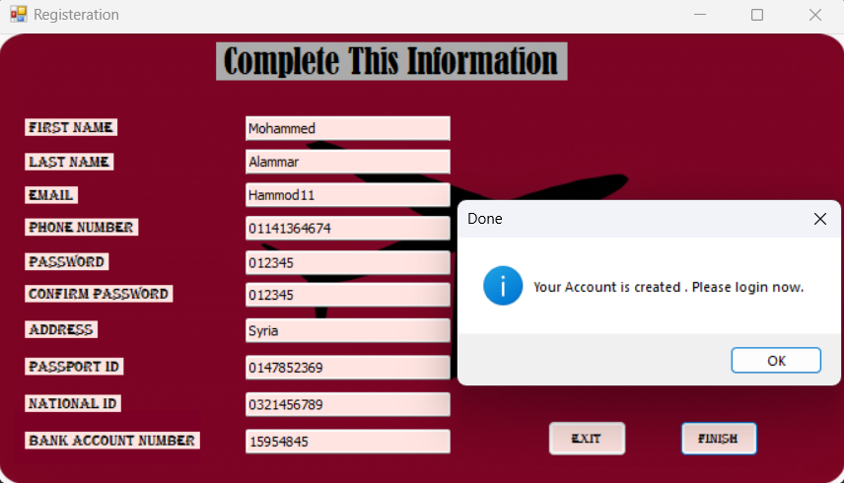3rd passenger registration: -

4th offers page: -

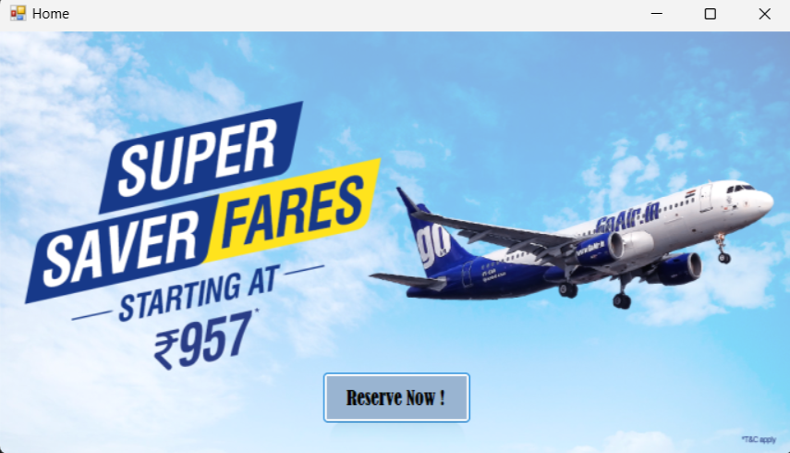

5th reservation page: -

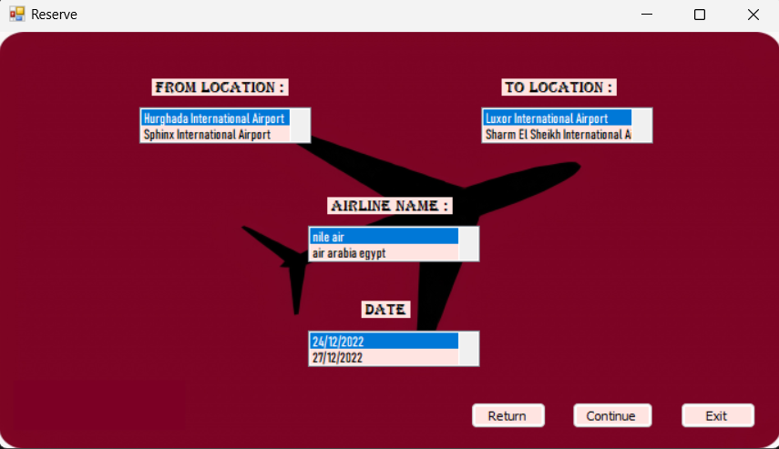

6th ticket information page: -

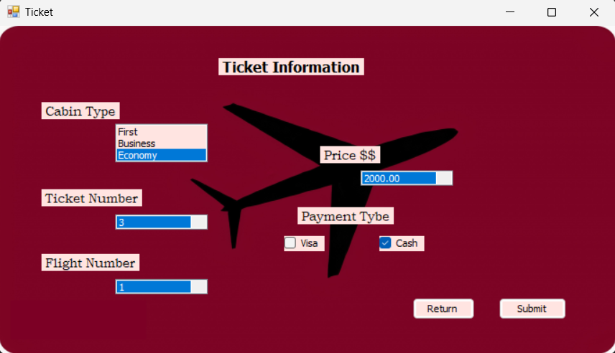

7th admin login page: -

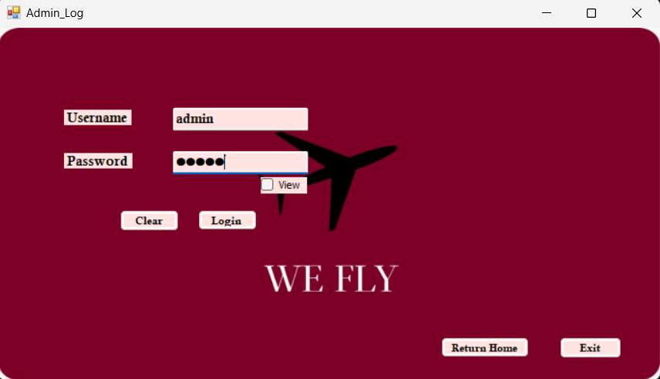

8th admin interface: -

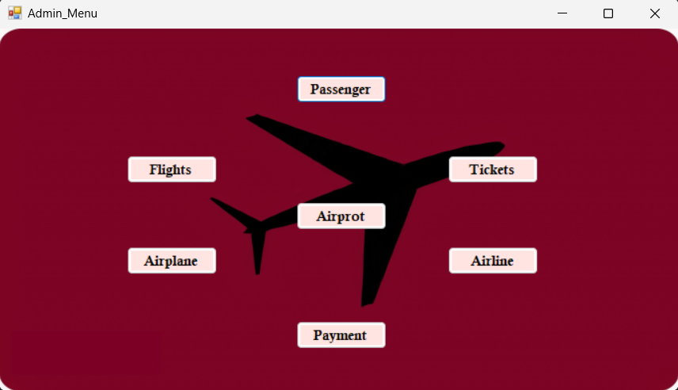

9th passenger’s database from admin’s perspective: -

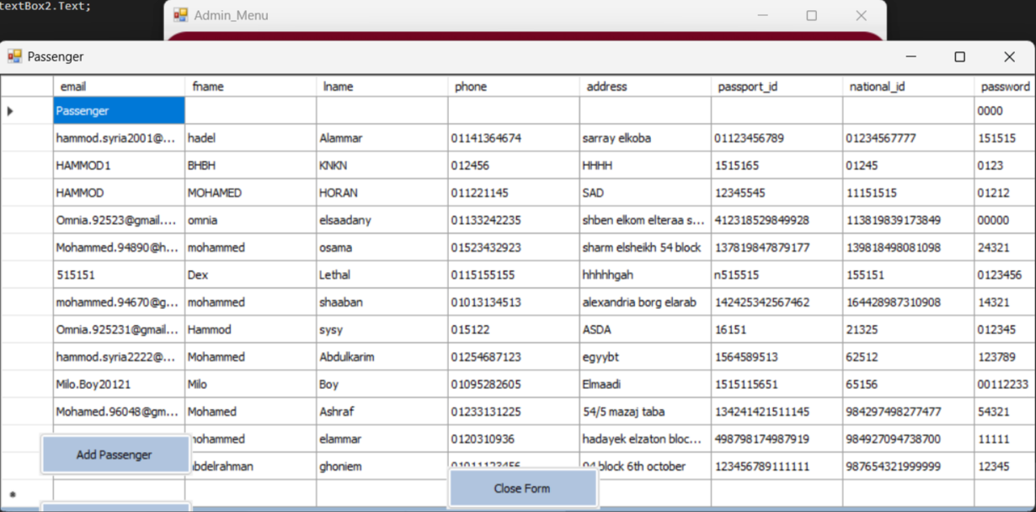

# Test case: -